N icon, redN icon, red

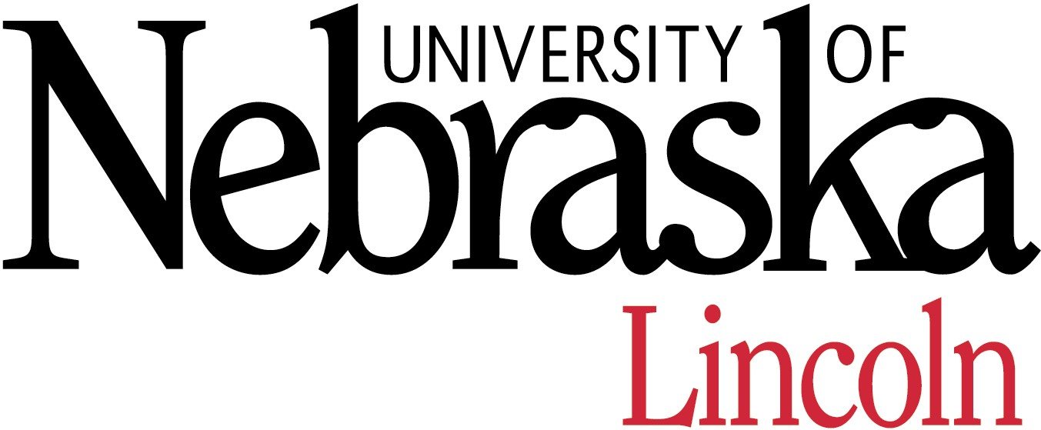

**GRADUATE ASSISTANTSHIPS IN DEBATE**

**UNIVERSITY OF NEBRASKA-LINCOLN**

**The University of Nebraska-Lincoln is seeking highly motivated Graduate Teaching Assistants with debate experience to work with a nationally competitive speech and debate program as they pursue their masters or doctoral degree.**

The UNL Speech & Debate program has a long and storied history and we are looking for dedicated individuals to continue that tradition. The forensics program has existed at UNL for over one-hundred years and during that time has enjoyed tremendous success. The UNL team has placed in the top 20 at the American Forensics Associations National Individual Events Tournament for 22 consecutive years and has produced six national champions since 2000. The Lincoln Douglas Debate team has placed in the top 5 at the National Forensics Association’s National Tournament four of the last seven years.

We are looking for a debate assistant with competition and/or coaching experience. The position requires weekly coaching and travel to at least four tournaments a semester. The team travels regularly to regional and national tournaments. We are currently looking for individuals with collegiate experience in speech who has desire to work with and teach undergraduate students. A qualified candidate should be able to work with fellow coaches and colleges, as well as be a diligent student in the graduate program. UNL also offers forensics GTAs the opportunity to teach courses in the department as well. We are looking for MA and PhD level candidates.

UNL offers the opportunity for *close working and mentoring relationships* with faculty members and your fellow students. We focus intensely on a small and close community of in-residence graduate students. UNL offers MA and Ph.D. degrees, specializing in: Interpersonal, Family & Intergroup Communication, Health Communication, and Rhetoric and Public Culture..

*Lincoln* is a wonderfully vibrant place of 230,000 people. Big enough to be a medium-sized city and small enough to maintain a neighborly feel. The downtown area, right next to the university, is dotted with wonderful restaurants, coffeehouses, theaters, and bookstores. Lincolnites enjoy an excellent quality of life with low crime, very affordable housing, parks, cultural events and clean air. Our students fall in love with the place. For more information, check out these websites http://www.lincoln.org/ <http://www.lincoln.ne.gov/> <http://www.lcoc.com/>

To complete the application process, apply to both UNL Graduate Studies <http://www.unl.edu/gradstud> and the Department of Communication Studies comm.unl.edu application form on website). We begin reviewing Fall applications the second week in January and proceed until positions are filled.

**If you have questions about the University of Nebraska-Lincoln's graduate program please contact Director of Graduate Studies Dr. Jordan Soliz jsoliz2@unl.edu>. Questions about the forensics team may be directed to Director of Forensics Aaron Duncan** [**aduncan3@unl.edu**](mailto:aduncan3@unl.edu)**.**

We will also be at the Thursday Grad Fair at the NCA convention and at the department’s open house on Saturday night location TBD.